Herve TCHIENKIO

NWIT-105

Prof. Robert DENSOCK

October 17, 2024

**Class Project Part 3: Add a Cloudwatch Alarm**

*Screenshot of your Task Manager window*

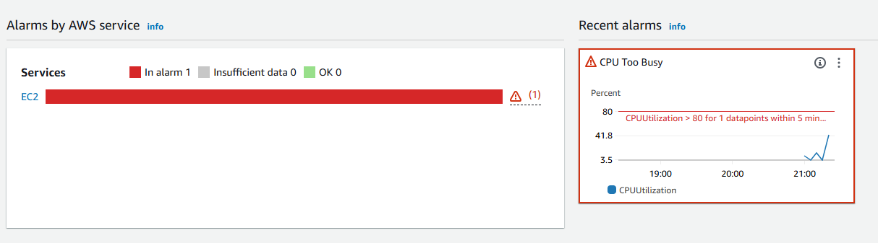

*Screenshot of my CloudWatch Alarm screen showing the “In Alarm” status*

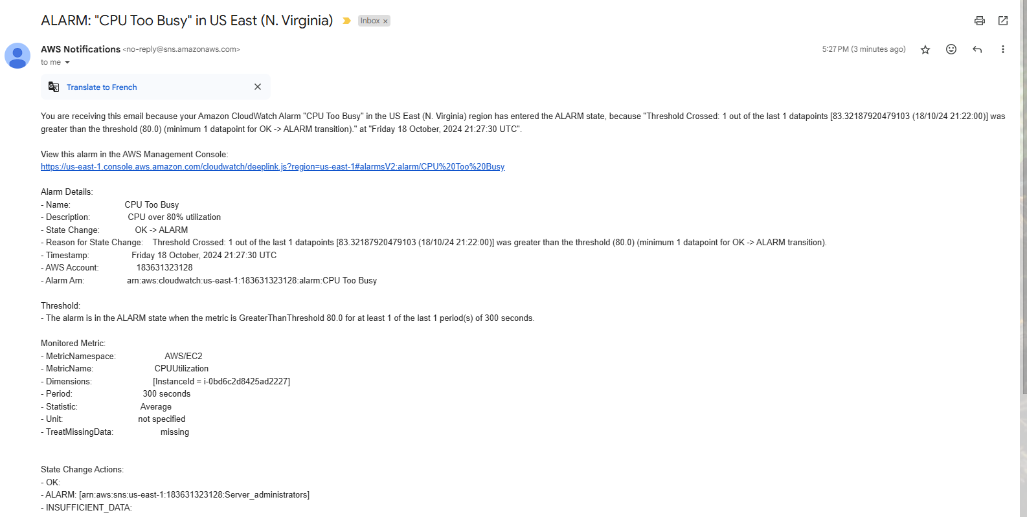

*Snapshot of your email alarm message*